Title
Minimum Cost to Climb with Variable Steps Using Dynamic Programming
INTRODUCTION
To determine the minimum cost required to reach the top of a staircase when up to k steps can be climbed at a time.Each step of a staircase has an associated cost. A person may jump up to k steps in one move. The goal is to reach the top while minimizing the total cost incurred.
Approach
Dynamic Programming is used to avoid repeated calculations and efficiently compute the minimum cost path.
Algorithm
- Create a DP array.
- Store the minimum cost to reach each step.
- For each step, consider the previous k steps.
- Choose the minimum among them and add the current step cost.
- The answer is the minimum cost among the last k steps.
PROGRAM:

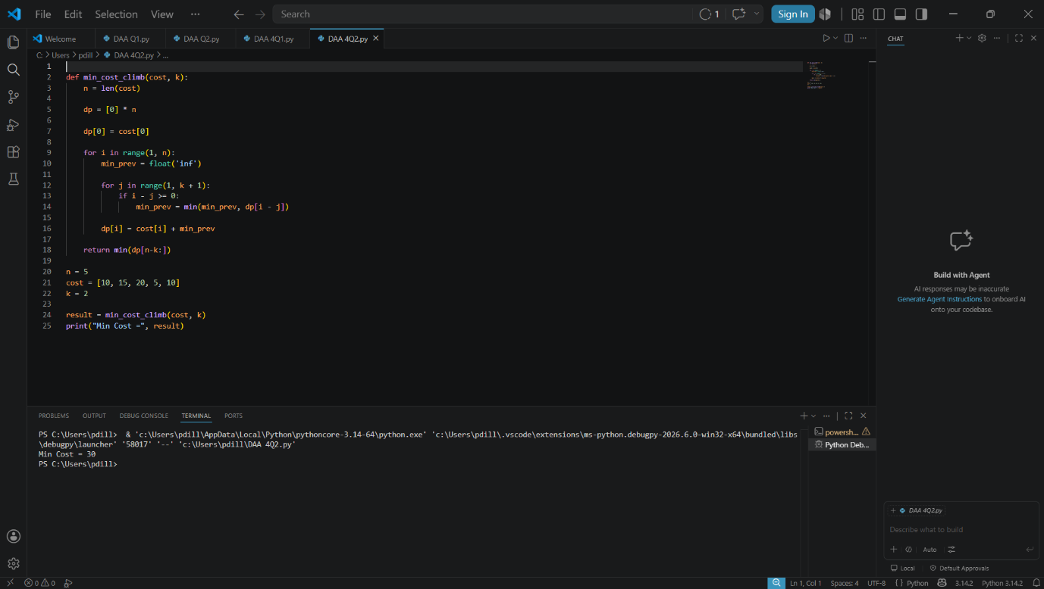

Time Complexity
Complexity Type | Value
Time Complexity | O(n × k)
Space Complexity | O(n)
Applications
- Robot path planning
- Resource optimization
- Energy-efficient movement systems
- Game development
Advantages
- Avoids redundant calculations.
- Efficient compared to recursion.
- Suitable for large inputs.
Conclusion
Dynamic Programming provides an efficient solution for finding the least cost path while allowing variable jumps. It significantly reduces computation time and ensures optimal results.

